**CSE421 Project Topic 3**

**Group 29**

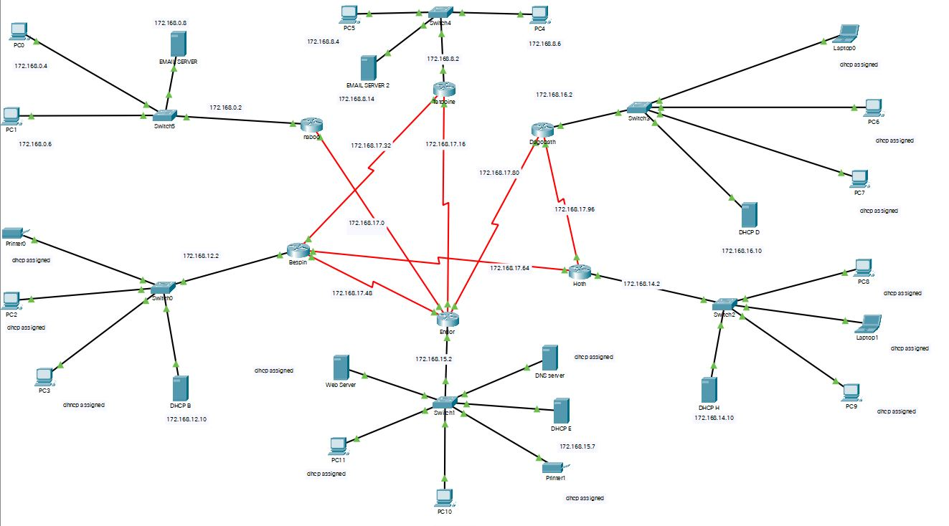

**VLSM**

|  |  |  |  |
| --- | --- | --- | --- |
| **Name** | **Network Address** | **Slash** | **Mask** |
| Naboo (1024) | 172.168.0.0 | /21 | 255.255.248.0 |
| Tatooine (526) | 172.168.8.0 | /22 | 255.255.252.0 |
| Bespin (312) | 172.168.12.0 | /23 | 255.255.254.0 |
| Hoth (234) | 172.168.14.0 | /24 | 255.255.255.0 |
| Endor (156) | 172.168.15.0 | /24 | 255.255.255.0 |
| Dagobath (128) | 172.168.16.0 | /24 | 255.255.255.0 |
| Naboo -- Endor | 172.168.17.0 | /28 | 255.255.255.240 |
| Endor -- Tatooine | 172.168.17.16 | /28 | 255.255.255.240 |
| Tatooine -- Bespin | 172.168.17.32 | /28 | 255.255.255.240 |
| Endor -- Bespin | 172.168.17.48 | /28 | 255.255.255.240 |
| Bespin -- Hoth | 172.168.17.64 | /28 | 255.255.255.240 |
| Dagobath -- Endor | 172.168.17.80 | /28 | 255.255.255.240 |
| Dagobath -- Hoth | 172.168.17.96 | /28 | 255.255.255.240 |

**Addressing Table**

|  |  |  |  |  |
| --- | --- | --- | --- | --- |
| **Device** | **Interface** | **IPV4 Address** | **Subnet Mask** | **Default Gateway** |
| **Naboo** | F0/0 | 172.168.0.2 | 255.255.248.0 |  |
| S0/0/0 | 172.168.17.2 | 255.255.255.240 |  |
| **Tatooine** | F0/0 | 172.168.8.2 | 255.255.252.0 |  |
| S0/0/0 | 172.168.17.36 | 255.255.255.240 |  |
| S0/0/1 | 172.168.17.20 | 255.255.255.240 |  |
| **Bespin** | F0/0 | 172.168.12.2 | 255.255.254.0 |  |
| S0/0/0 | 172.168.17.68 | 255.255.255.240 |  |
| S0/0/1 | 172.168.17.34 | 255.255.255.240 |  |
|  | S0/1/0 | 172.168.17.52 | 255.255.255.240 |  |
| **Hoth** | F0/0 | 172.168.14.2 | 255.255.255.0 |  |
| S0/0/0 | 172.168.17.100 | 255.255.255.240 |  |
| S0/0/1 | 172.168.17.66 | 255.255.255.240 |  |
| **Endor** | F0/0 | 172.168.15.2 | 255.255.255.0 |  |
| S0/0/0 | 172.168.17.4 | 255.255.255.240 |  |
| S0/0/1 | 172.168.17.84 | 255.255.255.240 |  |
|  | S0/1/0 | 172.168.17.18 | 255.255.255.240 |  |
|  | S0/1/1 | 172.168.17.50 | 255.255.255.240 |  |
| **Dagobath** | F0/0 | 172.168.16.2 | 255.255.255.0 |  |
| S0/0/0 | 172.168.17.82 | 255.255.255.240 |  |
| S0/0/1 | 172.168.17.98 | 255.255.255.240 |  |
|  | S0/1/0 | 172.168.17.52 | 255.255.255.248 |  |
| **PC0** | NIC | 172.168.0.4 | 255.255.255.248 | 172.168.0.2 |
| **PC1** | NIC | 172.168.0.6 | 255.255.248.0 | 172.168.0.2 |
| **PC2** | NIC | DHCP assigned | DHCP assigned | DHCP assigned |
| **PC3** | NIC | DHCP assigned | DHCP assigned | DHCP assigned |
| **PC4** | NIC | 172.168.8.6 | 255.255.252.0 | 172.168.8.2 |
| **PC5** | NIC | 172.168.8.4 | 255.255.252.0 | 172.168.8.2 |
| **PC6** | NIC | DHCP assigned | DHCP assigned | DHCP assigned |
| **PC7** | NIC | DHCP assigned | DHCP assigned | DHCP assigned |
| **PC8** | NIC | DHCP assigned | DHCP assigned | DHCP assigned |
| **PC9** | NIC | DHCP assigned | DHCP assigned | DHCP assigned |
| **PC10** | NIC | DHCP assigned | DHCP assigned | DHCP assigned |
| **PC11** | NIC | DHCP assigned | DHCP assigned | DHCP assigned |
| **Laptop0** | NIC | DHCP assigned | DHCP assigned | DHCP assigned |
| **Laptop1** | NIC | DHCP assigned | DHCP assigned | DHCP assigned |
| **Printer0** | NIC | DHCP assigned | DHCP assigned | DHCP assigned |
| **Printer1** | NIC | DHCP assigned | DHCP assigned | DHCP assigned |
| **DHCP D** | NIC | 172.168.16.10 | 255.255.255.0 | 172.168.16.2 |
| **DHCP H** | NIC | 172.168.14.10 | 255.255.255.0 | 172.168.14.2 |
| **DHCP E** | NIC | 172.168.15.7 | 255.255.255.0 | 172.168.15.2 |
| **DHCP B** | NIC | 172.168.12.10 | 255.255.254.0 | 172.168.12.2 |
| **WEB SERVER** | NIC | DHCP assigned | DHCP assigned | DHCP assigned |
| **DNS SERVER** | NIC | DHCP assigned | DHCP assigned | DHCP assigned |
| **EMAIL SERVER** | NIC | 172.168.0.8 | 255.255.248.0 | 172.168.0.2 |
| **EMAIL SERVER2** | NIC | 172.168.8.14 | 255.255.252.0 | 172.168.8.2 |

**Commands**

|  |
| --- |
| **Naboo:**  en  conf t  RN(config)#ip route 172.168.15.0 255.255.255.0 s0/0/0  RN(config)#ip route 172.168.8.0 255.255.252.0 s0/0/0  RN(config)#ip route 172.168.12.0 255.255.254.0 s0/0/0  RN(config)#ip route 172.168.8.0 255.255.252.0 s0/0/0 130  RN(config)#ip route 172.168.12.0 255.255.254.0 s0/0/0 140  RN(config)#ip route 172.168.16.0 255.255.255.0 s0/0/0  RN(config)#ip route 172.168.14.0 255.255.255.0 s0/0/0  RN(config)#ip route 172.168.12.0 255.255.254.0 s0/0/0  **Endor:**  en  conf t  Router(config)#ip route 172.168.0.0 255.255.248.0 s0/0/0  Router(config)#ip route 172.168.16.0 255.255.255.0 s0/0/1  Router(config)#ip route 172.168.14.0 255.255.255.0 s0/0/1  Router(config)#ip route 172.168.12.0 255.255.254.0 s0/0/1  Router(config)#ip route 172.168.8.0 255.255.252.0 s0/0/1  Router(config)#ip route 172.168.12.0 255.255.254.0 s0/1/1 150  Router(config)#ip route 172.168.8.0 255.255.252.0 s0/1/0 160  **Dagobath:**  en  conf t  Router(config)#ip route 172.168.15.0 255.255.255.0 s0/0/0  Router(config)#ip route 172.168.14.0 255.255.255.0 s0/0/1  Router(config)#ip route 172.168.12.0 255.255.254.0 s0/0/1  Router(config)#ip route 172.168.8.0 255.255.252.0 s0/0/1  Router(config)#ip route 172.168.15.0 255.255.255.0 s0/0/1 170  Router(config)#ip route 172.168.0.0 255.255.24.0 s0/0/0  Router(config)#ip route 172.168.0.0 255.255.252.0 s0/0/0  Router(config)#ip route 172.168.8.0 255.255.252.0 s0/0/0 180  Router(config)#ip route 172.168.12.0 255.255.254.0 s0/0/0 190  **Hoth:**  en  conf t  router rip  version 2  no auto-summary  reditrubute static  redistribute connected  Router(config-router)#network 172.168.14.0  Router(config-router)#network 172.168.17.0  Router(config-router)#network 172.168.17.16  Router(config-router)#network 172.168.17.32  Router(config-router)#network 172.168.17.48  Router(config-router)#network 172.168.17.64  Router(config-router)#network 172.168.17.80  Router(config-router)#network 172.168.17.96  **Bespin:**  en  conf t  router rip  version 2  no auto-summary  reditrubute static  redistribute connected  Router(config-router)#network 172.168.12.0  Router(config-router)#network 172.168.17.0  Router(config-router)#network 172.168.17.16  Router(config-router)#network 172.168.17.32  Router(config-router)#network 172.168.17.48  Router(config-router)#network 172.168.17.64  Router(config-router)#network 172.168.17.80  Router(config-router)#network 172.168.17.96  **Tatooine:**  en  conf t  router rip  version 2  no auto-summary  reditrubute static  redistribute connected  Router(config-router)#network 172.168.8.0  Router(config-router)#network 172.168.17.0  Router(config-router)#network 172.168.17.16  Router(config-router)#network 172.168.17.32  Router(config-router)#network 172.168.17.48  Router(config-router)#network 172.168.17.64  Router(config-router)#network 172.168.17.80  Router(config-router)#network 172.168.17.96  Web Lin:  www.bounty.com |